**Pouring Liquid from a Small Pitcher or Carton into a Glass or Cup**

This routine requires that the child is seated in a safe position in a chair at a table and able to reach and manipulate materials on the table. An adult or older child places a small pitcher or open carton containing water or another liquid that the child likes to drink on the table within the child’s reach. A cup or glass is also placed on the table in front of the child.

[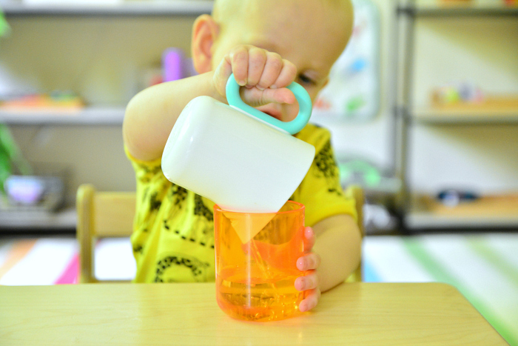](https://www.google.com/url?sa=i&url=https%3A%2F%2Fwww.howwemontessori.com%2Fhow-we-montessori%2F2019%2F05%2Flovevery-for-montessori-toddlers.html&psig=AOvVaw24cNUg8i7BKBug-WQk9g37&ust=1588879627923000&source=images&cd=vfe&ved=0CAIQjRxqFwoTCPjn3-78n-kCFQAAAAAdAAAAABAD)

1. Pick up pitcher/carton in dominant hand (the hand that is mostly used for writing/picking up things)
2. Hold cup/glass upright on table with other hand (the helping hand)
3. Tip pitcher/carton to pour liquid into cup
4. Stop pouring before the cup is full
5. Place pitcher/carton upright on table (Ready to drink liquid)

(PIRS Team: Barbara Berger, Susan Monfet, Janice Torres, Simone Smith)

**Drinking from a Glass when Seated at a Table**



1. Pick up glass from table with dominant hand (the hand that is mostly used for writing/picking up things)

2. Lift glass to mouth, keeping it level enough to avoid spilling

3. Place glass against lower lip

4. Open mouth

5. Tip glass to allow small amount of liquid into mouth

6. Close lips to retain liquid

7. Move glass away from lips and into upright position

8. Swallow liquid

9. Lower glass to table, keeping it level enough to avoid spilling

10. Place glass upright on table (Repeat using these steps to take drinks from the glass until the liquid is gone or until satisfied)

(PIRS Team: Barbara Berger, Susan Monfet, Janice Torres, Simone Smith)